**Timeline**

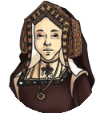

|  |  |
| --- | --- |
| **Key Events** | |
| **1485** | Henry Tudor is crowned King Henry VII. |
| **1509** | Henry VII dies. His son, Henry VIII becomes King. |
| **1534** | Henry VIII forms the Church of England, separating it from the Roman Catholic Church. |
| **1547** | Henry VIII dies. His son, Edward VI becomes King aged 9 years old. |
| **1553** | Edward VI dies and the **throne** is given to Lady Jane Grey (Edward’s cousin once removed) for just 9 days before Mary I takes the **throne**. |
| **1558** | Mary I dies. Her half-sister  Elizabeth I is Queen of England. |
| **1588** | The Spanish Armada is defeated by the English. |
| **1603** | Queen Elizabeth I dies ending the Tudor **reign**. |

|  |  |
| --- | --- |
| **Tudor Monarchs** | |
| **Henry VII** | The first Tudor King to **reign** over England after defeating Richard III in the  Battle of Bosworth Field. |
| **Henry VIII** | Became King aged 17. He married six times in the hope of having a son to be  his **heir** to the **throne**. |
| **Edward VI** | Henry VIII’s son. He was King for just a few years from aged 9 to 15 years  old but was considered too young to exercise power as the King. |
| **Lady Jane Grey** | After Edward VI died, Jane became Queen for just nine days before Mary  (the rightful **heir** to the **throne**) imprisoned her. |
| **Mary I** | Henry VIII’s daughter. Nicknamed ‘Bloody Mary’ after burning people at the  stake if they didn’t agree to the religious changes she made to the country. |
| **Elizabeth I** | Daughter of Henry VIII. She **reigned** for nearly 45 years and led the English  navy to defeat the Spanish Armada. She never married or had any children so when she died, the Tudor era ended. |

|  |  |  |  |  |  |  |
| --- | --- | --- | --- | --- | --- | --- |
| **Henry VIII’s Wives** | Catherine of Aragon (divorced) | Anne Boleyn (beheaded) | Jane Seymour (died) | Anne of Cleves (divorced) | Catherine Howard (beheaded) | Katherine Parr (survived) |



**1837 - 1901**

Victorian

**1714 - 1837**

Georgian

**1603 - 1714**

Stuarts

**1485 - 1603**

Tudors

**1154 - 1485**

Middle Ages

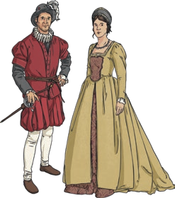

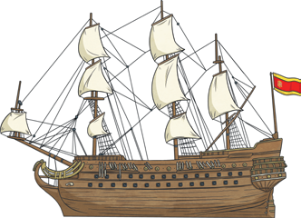

Philip II of Spain sent the Spanish Armada to England in 1588. England and Spain were at odds with each other due to religious reasons and England had helped rebels attack

Spanish treasure fleets. 130 ships, 30 000 troops and 2500 guns were sent to attack England but they were quickly defeated by the English navy.

**The Spanish Armada**

William Shakespeare was a famous poet, playwright and actor of the Tudor times. He wrote many plays including Romeo and Juliet and A Midsummer Night’s Dream which were performed at the Globe Theatre in London.

**Shakespeare**

* Food was seen as a sign of wealth.
* Bread, butter, cheese, eggs, fish and meat were usually on the menu along with potage (a vegetable broth thickened with oats.)
* Meat could include beef, pork, lamb, rabbit,

pheasant, deer, goose, wild boar and pigeon.

* Henry VIII often ate swan and seagull.
* Water was not used as a drink as it was thought to be unsafe. People, including children, would drink weak ale instead.

**Food and Drink**

Tudor clothing was lavish. Wealthy Tudors’ clothes would be decorated with gold and jewels.

Middle class Tudors’ clothes were much plainer and poor

Tudors would wear simple, loose fitting cotton clothes.

**Tudor Clothes**

|  |  |
| --- | --- |
| **Key Vocabulary** | |
| **heir** | A person who will inherit the **throne** when the current King or Queen dies. |
| **monarch** | A person who rules over a place, usually a king or queen. |
| **reign** | To rule over a country as a **monarch**. |
| **throne** | The position of a king or queen. |
| **The Age of Exploration** | A time when European nations began exploring the world. Also known as The Age of Discovery. This was from the 1400s to 1600s. |

|  |
| --- |
| **Tudor Houses** |
| Ordinary Tudor houses were made from a framework of wooden beams with wattle and daub (sticks and twigs mixed with clay and dung) attached between the frame. The wattle and daub was painted white leaving the beams exposed.  In poor Tudor houses, chimneys were just a hole in the roof to let out smoke. Windows were made from animal’s horns or paper. |
| Wealthy Tudor houses were built from bricks in a symmetrical formation. Chimneys were tall and ornate. Windows were a sign of wealth so rich Tudors had as many windows as possible. |